YEAR 11 HUMAN BIOLOGY CIRCULATION TEST

INTERNAL TRANSPORT

SECTION A: MULTIPLE CHOICE (20 MARKS)

1. The normal period of one complete cardiac cycle in an adult is about

(a) 0.08 seconds
(b) 0.8 seconds
(c) 1.8 seconds
(d) 8.0 seconds

2. The outer covering of the heart is called the

(a) myocardium
(b) pericardium
(c) endocardium
(d) periosteum

3. The two largest veins in the body are

(a) hepatic and hepatic portal veins
(b) superior and inferior venae cavae
(c) left and right pulmonary veins
(d) pulmonary artery and aorta

4. Vessels entering the heart are called

(a) arterioles
(b) veins
(c) arteries
(d) venules

5. The period during which the heart rests is known as

(a) cardiac systole
(b) cardiac diastole
(c) cardiac cycle
(d) ventricular systole

6. Which of the following arteries supplies blood to the head?

(a) carotid artery
(b) renal artery
(c) coronary artery
(d) pulmonary artery

7. The blood leaves the right ventricle via the

(a) left artrium
(b) pulmonary22 artery
(c) vena cava
(d) aorta

8. The proportion of red blood cells to white blood cells in human blood is

(a) 6000 : 1
(b) 500 : 1
(c) 5,000,000 : 1
(d) 10,000 : 1

9. Any undue loss of blood from the circulatory system is termed a/an

(a) haemorrhage
(b) thrombosis
(c) agglutination
(d) haemophilia

10. In adults red blood cells are manufactured mainly in

(a) the marrow of the long bones and the spleen
(b) the spleen
(c) the marrow of the long bones
(d) the marrow of the ribs and the sternum

11. Leucocytes are responsible for

(a) phagocytosis of foreign particles
(b) carrying oxygen around the body
(c) haemoglobin production
(d) synthesis of fibrinogen

12. Blood cells which have no nucleus are

(a) leucocytes
(b) monocytes
(c) erythrocytes
(d) white corpuscles

13. A main function of the spleen is to

(a) produce insulin
(b) to store glucose
(c) to destroy leucocytes
(d) to destroy erythrocytes

14. The portal circulation

(a) takes blood to the intestines
(b) returns blood to the heart
(c) removes waste products from the blood
(d) returns liver blood to the heart

15. A person suffering from anaemia is unable to carry out prolonged exercise because

(a) waste products cannot be removed rapidly enough
(b) the amount of sugar being carried to the cells would not be enough for rapid cellular respiration
(c) the concentration of carbon dioxide in the extra cellular fluid would become too high
(d) insufficient oxygen can be carried by the blood

16. Capillaries

(a) carry deoxygenated blood only
(b) connect the blood and lymphatic systems
(c) carry blood away from the veins
(d) connect arterioles to venules

17. The greatest work effort of the cardiac muscle is exerted by the

(a) right atrium
(b) left atrium
(c) right ventricle
(d) left ventricle

18. In making a complete circuit through the human body, blood passes through the heart

(a) once
(b) twice
(c) three times
(d) four times

19. Blood is returned through the veins with the help of

(a) muscular contractions of the walls of the veins
(b) the pumping action of the heart
(c) contraction of muscles surrounding the veins
(d) a pulse wave

20. Which of the following is produced in the lymph nodes

(a) fibrinogen
(b) red blood cells
(c) white blood cells
(d) red blood cells and white blood cells

YEAR 11 HUMAN BIOLOGY CIRCULATION TEST

INTERNAL TRANSPORT

SECTION B: SHORT ANSWER (20 MARKS)

Name ______________________________

Answer the questions in the spaces provided.

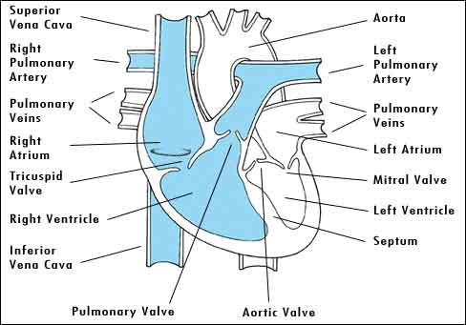

21. (a) Label the parts arrowed. (7 marks)

(b) Draw arrows to show the flow of blood through the heart. (3 marks)

22. Outline the main differences between arteries, veins and capillaries.
Account for these differences.
____________________________________________________________________________________________________________________________________________________________________________________________________________________________________________________________________________________________________________________________________________________________________________________________________________________________________________________________
(4 marks)

23. (a) List four factors affecting a persons blood pressure.
____________________________________________________________________________________________________________________________________________________________________________________________________________________________________________________________________________________________________________________________________________________________________________________________________________________________________________________________
(2 marks)

(b) A persons blood pressure is 120 – 80 Explain the meaning of these figures.
____________________________________________________________________________________________________________________________________________________________________________________________________________________________________________________________________________________________________________________________________________________________________________________________________________________________________________________________
(2 marks)

24. Using a simple labelled diagram show the relationship between cells, capillaries, tissue fluid, and lymph vessels.

(2 marks)

TOTAL MARKS = /20

